HR Analytics Dashboard

Employee Attrition Analysis Report
Tools Used: SQL (MySQL) | Microsoft Power BI

Prepared by: Noor Mohammad

15th Jun 2026

Table of Contents
Table of Contents 1
1. Executive Summary 1
Key Metrics Overview 1
2. Project Objective 1
3. Methodology and Tools 1
3.1 Data Cleaning and Querying (SQL - MySQL) 1
3.2 Data Analysis (Python - Pandas) 1
3.3 Dashboard Development (Power BI) 1
4. Dashboard Overview 1
4.1 Top-Level KPI Cards 1
4.2 Employee Experience Score Distributions 1
4.3 Attrition by Business Travel and Overtime 1
4.4 Attrition by Years in Current Role and Distance from Home 1
4.5 Attrition by Department and Education 1
4.6 Attrition by Salary Hike Percentage 1
4.7 Attrition Rate by Job Role 1
5. Key Findings and Insights 1
6. Recommendations 1
7. Conclusion 1

1. Executive Summary
This report presents an end-to-end analysis of employee attrition for Tech IT Solutions, it’s a service-based company that provides IT and business support services across various industries such as finance, healthcare, and retail. With a workforce of around 10,000 employees, the company noticed increasing employee turnover affecting project delivery and team stability. The analysis was conducted using a combination of SQL for database connection and Power BI for building an interactive dashboard that enables HR stakeholders to explore attrition trends across multiple dimensions.
The dashboard reveals that the organization has experienced significant attrition, with 2,247 employees (22.47%) having left the company, leaving 7,753 active employees. The average age of the workforce is 40 years. Key drivers of attrition identified through this analysis include overtime requirements, frequent business travel, distance from home, low job satisfaction and involvement scores, and specific departments and job roles that show disproportionately high attrition rates.
The findings in this report aim to help HR leadership identify at-risk employee segments, understand the root causes of voluntary turnover, and design targeted retention strategies.

Key Metrics Overview
Metric | Value
Total Employees | 10,000
Total Attrition (Employees Left) | 2,247
Active Employees | 7,753
Attrition Rate | 22.47%
Average Age | 40 years

2. Project Objective
The primary objective of this project was to analyze historical HR data to understand the patterns and key factors contributing to employee attrition, and to present these insights through an interactive Power BI dashboard. Specific goals included:
- Calculate overall attrition rate and core workforce metrics (total, active, and exited employees).
- Identify which job roles, departments, and education levels have the highest attrition.
- Examine the relationship between attrition and work-related factors such as overtime, business travel, salary hikes, distance from home, and years in current role.
- Evaluate employee satisfaction indicators including job involvement, job satisfaction, job environment, and work-life balance.
- Build a filterable, interactive dashboard allowing HR teams to segment data by Job Role, Job Level, and Gender.

3. Methodology and Tools

3.1 Data Source and Connection (MySQL)
The HR dataset was hosted in a MySQL database, which served as the data source for the project. Power BI Desktop was connected directly to the MySQL database using the MySQL connector, allowing the dashboard to query the underlying employee records for live analysis.

3.2 Dashboard Development (Power BI - DAX and Visualizations)
The analysis and interactive dashboard were built entirely in Power BI Desktop. Key elements of the dashboard build included:
- DAX measures and calculated columns to compute KPIs such as Total Employees, Total Attrition, Active Employees, and Attrition Rate.
- Aggregation-based visuals (bar charts, donut charts, line charts, and treemaps) to break down attrition by department, job role, education level, business travel, overtime, distance from home, and years in current role.
- Cross-filtering slicers for Job Role, Job Level, and Gender, allowing dynamic exploration of attrition patterns.
- A global Reset button (using Power BI bookmarks) to clear all applied filters and return the dashboard to its default view.

4. Dashboard Overview
The Power BI dashboard is organized into several interconnected sections, each addressing a specific dimension of employee attrition. The dashboard includes interactive filters for Job Role, Job Level, and Gender, allowing HR users to drill into specific employee segments.
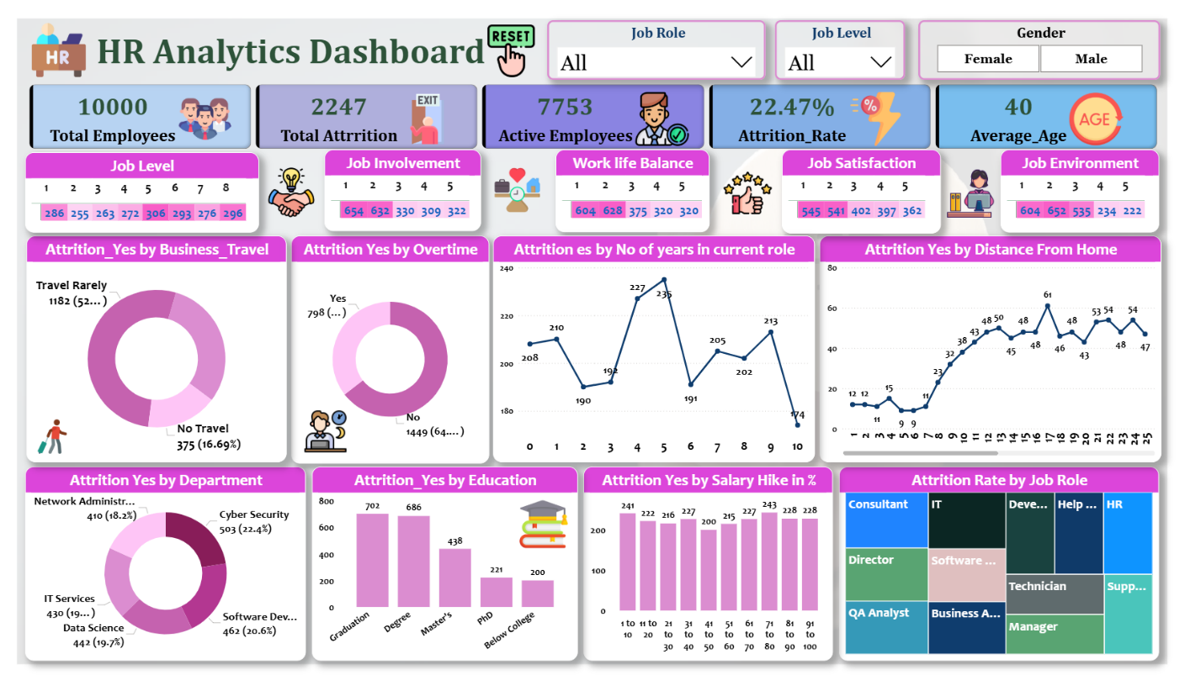

4.1 Top-Level KPI Cards
At the top of the dashboard, five KPI cards summarize the overall workforce composition and attrition status, providing an at-a-glance view: Total Employees (10,000), Total Attrition (2,247), Active Employees (7,753), Attrition Rate (22.47%), and Average Age (40).

4.2 Employee Experience Score Distributions
A row of horizontal score breakdowns displays the distribution of employees across rating scales (1 to 5, with Job Level on a 1 to 8 scale) for the following dimensions:
Dimension | Distribution (by rating level)
Job Level (1-8) | 286, 255, 263, 272, 306, 293, 276, 296
Job Involvement (1-5) | 654, 632, 330, 309, 322
Work-Life Balance (1-5) | 604, 628, 375, 320, 320
Job Satisfaction (1-5) | 545, 541, 402, 397, 362
Job Environment (1-5) | 604, 652, 535, 234, 222
These distributions show that a substantial proportion of employees rate their Job Involvement, Work-Life Balance, Job Satisfaction, and Job Environment at the lower end of the scale (ratings 1 and 2), which correlates with the elevated overall attrition rate observed in the organization.

4.3 Attrition by Business Travel and Overtime
Two donut charts examine attrition in relation to travel requirements and overtime status:
- Attrition (Yes) by Business Travel: Employees who 'Travel Rarely' account for the largest share of attrition at 1,182 cases (approximately 52%), followed by 'Travel Frequently', while employees with 'No Travel' represent 375 cases (16.69%).
- Attrition by Overtime: Employees working overtime ('Yes') represent 798 attrition cases, while those not working overtime ('No') account for 1,449 cases (approximately 64%) of total attrition.
While the raw attrition counts are higher among non-overtime employees due to their larger overall population, the overtime segment shows a markedly higher attrition rate, indicating that overtime is a strong individual risk factor for turnover despite the smaller absolute number.

4.4 Attrition by Years in Current Role and Distance from Home
A line chart tracks attrition counts against the number of years an employee has spent in their current role (0 to 10 years). Attrition is relatively low for employees with 0-3 years in role (190-227 range with an initial dip), peaks sharply at 4-5 years (227 and 235 cases), and fluctuates afterward before dropping significantly to 174 cases at year 10. This pattern suggests that the 4-5 year mark in a role represents a critical retention risk window, potentially linked to career stagnation or lack of promotion opportunities.
A second line chart shows attrition counts by distance from home (in kilometers/miles). Attrition remains low and stable (9-15 cases) for employees living within 0-7 units of distance, then rises sharply from 8 units onward, peaking at 61 cases at a distance of approximately 17 units, before fluctuating between 43 and 54 cases for distances beyond that. This indicates that employees with longer commutes are considerably more likely to leave the organization.

4.5 Attrition by Department and Education
The departmental breakdown shows attrition distributed across five departments:
Department | Attrition Count | Percentage of Total Attrition
Cyber Security | 503 | 22.4%
Software Development | 462 | 20.6%
Network Administration | 410 | 18.2%
Data Science | 442 | 19.7%
IT Services | 430 | 19.1%
Cyber Security has the highest attrition count among all departments (503, or 22.4% of total attrition), closely followed by Software Development (462, 20.6%) and Data Science (442, 19.7%). The relatively even distribution across departments (each contributing roughly 18-22%) suggests that attrition is a systemic, organization-wide issue rather than one isolated to a single department.

The education-level breakdown of attrition shows the following pattern:
Education Level | Attrition Count
Graduation | 702
Degree | 686
Master's | 438
PhD | 221
Below College | 200
Employees with Graduation and Degree-level education account for the largest share of attrition (702 and 686 cases respectively), together representing more than 60% of total attrition cases. This may reflect both the larger population of employees at these education levels and potentially greater external job mobility for this group.

4.6 Attrition by Salary Hike Percentage
Attrition counts were segmented into salary hike percentage bands (e.g., 1-10%, 11-20%, up to 91-100%). The data shows attrition counts remain relatively consistent across all salary hike bands, ranging from approximately 200 to 243 cases per band, with the highest attrition occurring in the 71-80% band (243 cases) and the lowest in the 41-50% band (200 cases). The relatively flat distribution suggests that salary hike percentage alone is not a strong standalone predictor of attrition and likely interacts with other factors such as job satisfaction and overtime.

4.7 Attrition Rate by Job Role
A treemap visualization breaks down attrition rate by job role, including Consultant, Director, QA Analyst, IT, Software Architect, Business Analyst, Developer, Help Desk, Technician, HR, Manager, and Support roles. The size of each tile is proportional to the relative attrition rate for that role, with Consultant and IT-related roles occupying some of the largest tile areas, indicating these roles experience comparatively higher attrition rates relative to others such as HR, Manager, and Support roles, which occupy smaller tile areas.

5. Key Findings and Insights
- Overall attrition rate stands at 22.47%, which is notably high and indicates a retention challenge affecting nearly one in four employees.
- Overtime is a significant attrition driver: employees who work overtime exhibit a disproportionately high attrition rate relative to their share of the workforce.
- Employees who 'Travel Rarely' make up the majority of attrition cases (52%), suggesting that travel frequency alone does not fully explain turnover and other factors (e.g., role dissatisfaction) play a larger role for this group.
- The 4-5 year mark in a current role is a critical attrition risk period, with attrition counts peaking at 227-235 cases during this tenure window.
- Longer commute distances (beyond approximately 8 units) are strongly associated with higher attrition, peaking at 61 cases around the 17-unit distance mark.
- Cyber Security, Software Development, and Data Science departments show the highest attrition counts, though the spread across departments (18-22% each) indicates a broad, organization-wide issue.
- Employees with Graduation and Degree-level qualifications represent the majority of attrition cases (over 60% combined).
- Salary hike percentage shows a relatively flat relationship with attrition, suggesting it is not a primary standalone driver.
- Lower-end ratings (1-2) in Job Involvement, Job Satisfaction, Work-Life Balance, and Job Environment are disproportionately represented, pointing to engagement and culture-related issues as contributing factors to attrition.
- Job roles such as Consultant and IT-related positions show comparatively higher attrition rates based on the treemap visualization.

6. Recommendations
- Review and rebalance overtime policies, particularly for high-attrition departments such as Cyber Security and Software Development, to reduce burnout-driven turnover.
- Introduce structured career development checkpoints for employees approaching the 4-5 year mark in their current role, including promotion pathways, skill development plans, or lateral movement opportunities.
- Explore remote or hybrid work options for employees with longer commute distances to mitigate attrition linked to distance from home.
- Conduct targeted engagement surveys and focus groups for employees rating Job Involvement, Job Satisfaction, and Work-Life Balance at 1 or 2, to identify and address specific pain points.
- Investigate role-specific retention strategies for Consultant and IT-related job roles, which show elevated attrition rates relative to other positions.
- Since salary hike alone does not strongly predict attrition, combine compensation reviews with non-monetary retention levers such as recognition programs, flexible scheduling, and career growth opportunities.
- Establish a recurring attrition monitoring cadence using the Power BI dashboard to track whether interventions are reducing attrition rates over time across departments and job roles.

7. Conclusion
This project demonstrates an end-to-end HR analytics workflow built entirely in Power BI, from connecting to a MySQL data source and performing data cleaning and transformation in Power Query, to developing DAX-driven KPIs and an interactive, decision-support dashboard. The analysis reveals that employee attrition at 22.47% is influenced by a combination of factors including overtime workload, commute distance, tenure in current role, departmental dynamics, and overall employee engagement scores.
By leveraging the interactive filters built into the dashboard (Job Role, Job Level, and Gender), HR stakeholders can further segment these findings to design and prioritize targeted retention initiatives. This project showcases practical, industry-relevant Power BI skills, including data modeling, Power Query transformations, DAX calculations, and dashboard design, applicable to real-world HR decision-making.

